Practical - 7
Practical Title: PHP Form Processing with Server-Side Validation and CSV/JSON File Storage
Problem Definition: Process submitted registration/contact form data using PHP. Validate and sanitize inputs on the server side and store records in CSV or JSON file format. Display success/error messages.

Theory
- Is the form submitted using POST?
Answer: Yes, the form is submitted using the POST method.

- Are inputs validated and sanitized server side?
Answer: Yes, inputs are validated and sanitized on the server side.

- Is file writing handled safely?
Answer: Yes, file writing is handled safely using CSV functions.

- Are success and error responses displayed clearly?
Answer: Yes, file writing is handled safely using CSV functions.

Implementation :
- Created a student registration form using HTML and PHP.
- Used POST method to securely submit form data.
- Added server-side validation and input sanitization.
- Stored student data safely in a CSV file.
- Displayed clear success and error messages.

Evidence of Work (Screenshots)
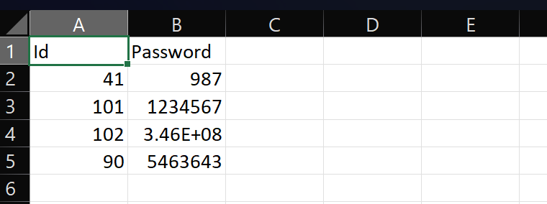
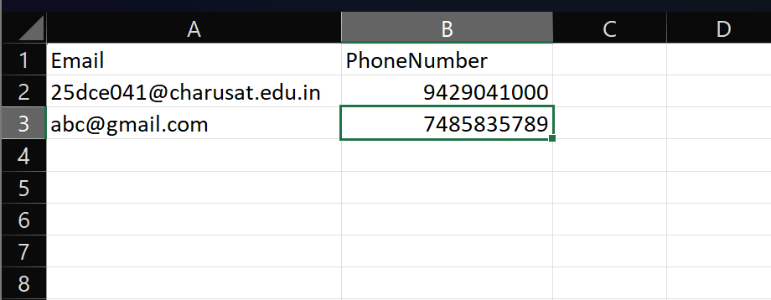

GitHub Repository Link:
https://github.com/kansagarahasti24/WDF

Challenges Faced:
- Handling form validation and error messages.
- Connecting HTML form data with PHP.
- Storing data correctly in a CSV file.
- Ensuring all fields are filled properly.
- Fixing errors during PHP execution.

Learning Outcomes:
- Learned to create forms using HTML and PHP.
- Learned server-side validation and data sanitization.
- Learned to store data in a CSV file using PHP.
- Learned to handle success and error messages.
- Improved understanding of PHP form processing.

Faculty Remarks: (Keep this blank for faculty)

